Membership Application Form | 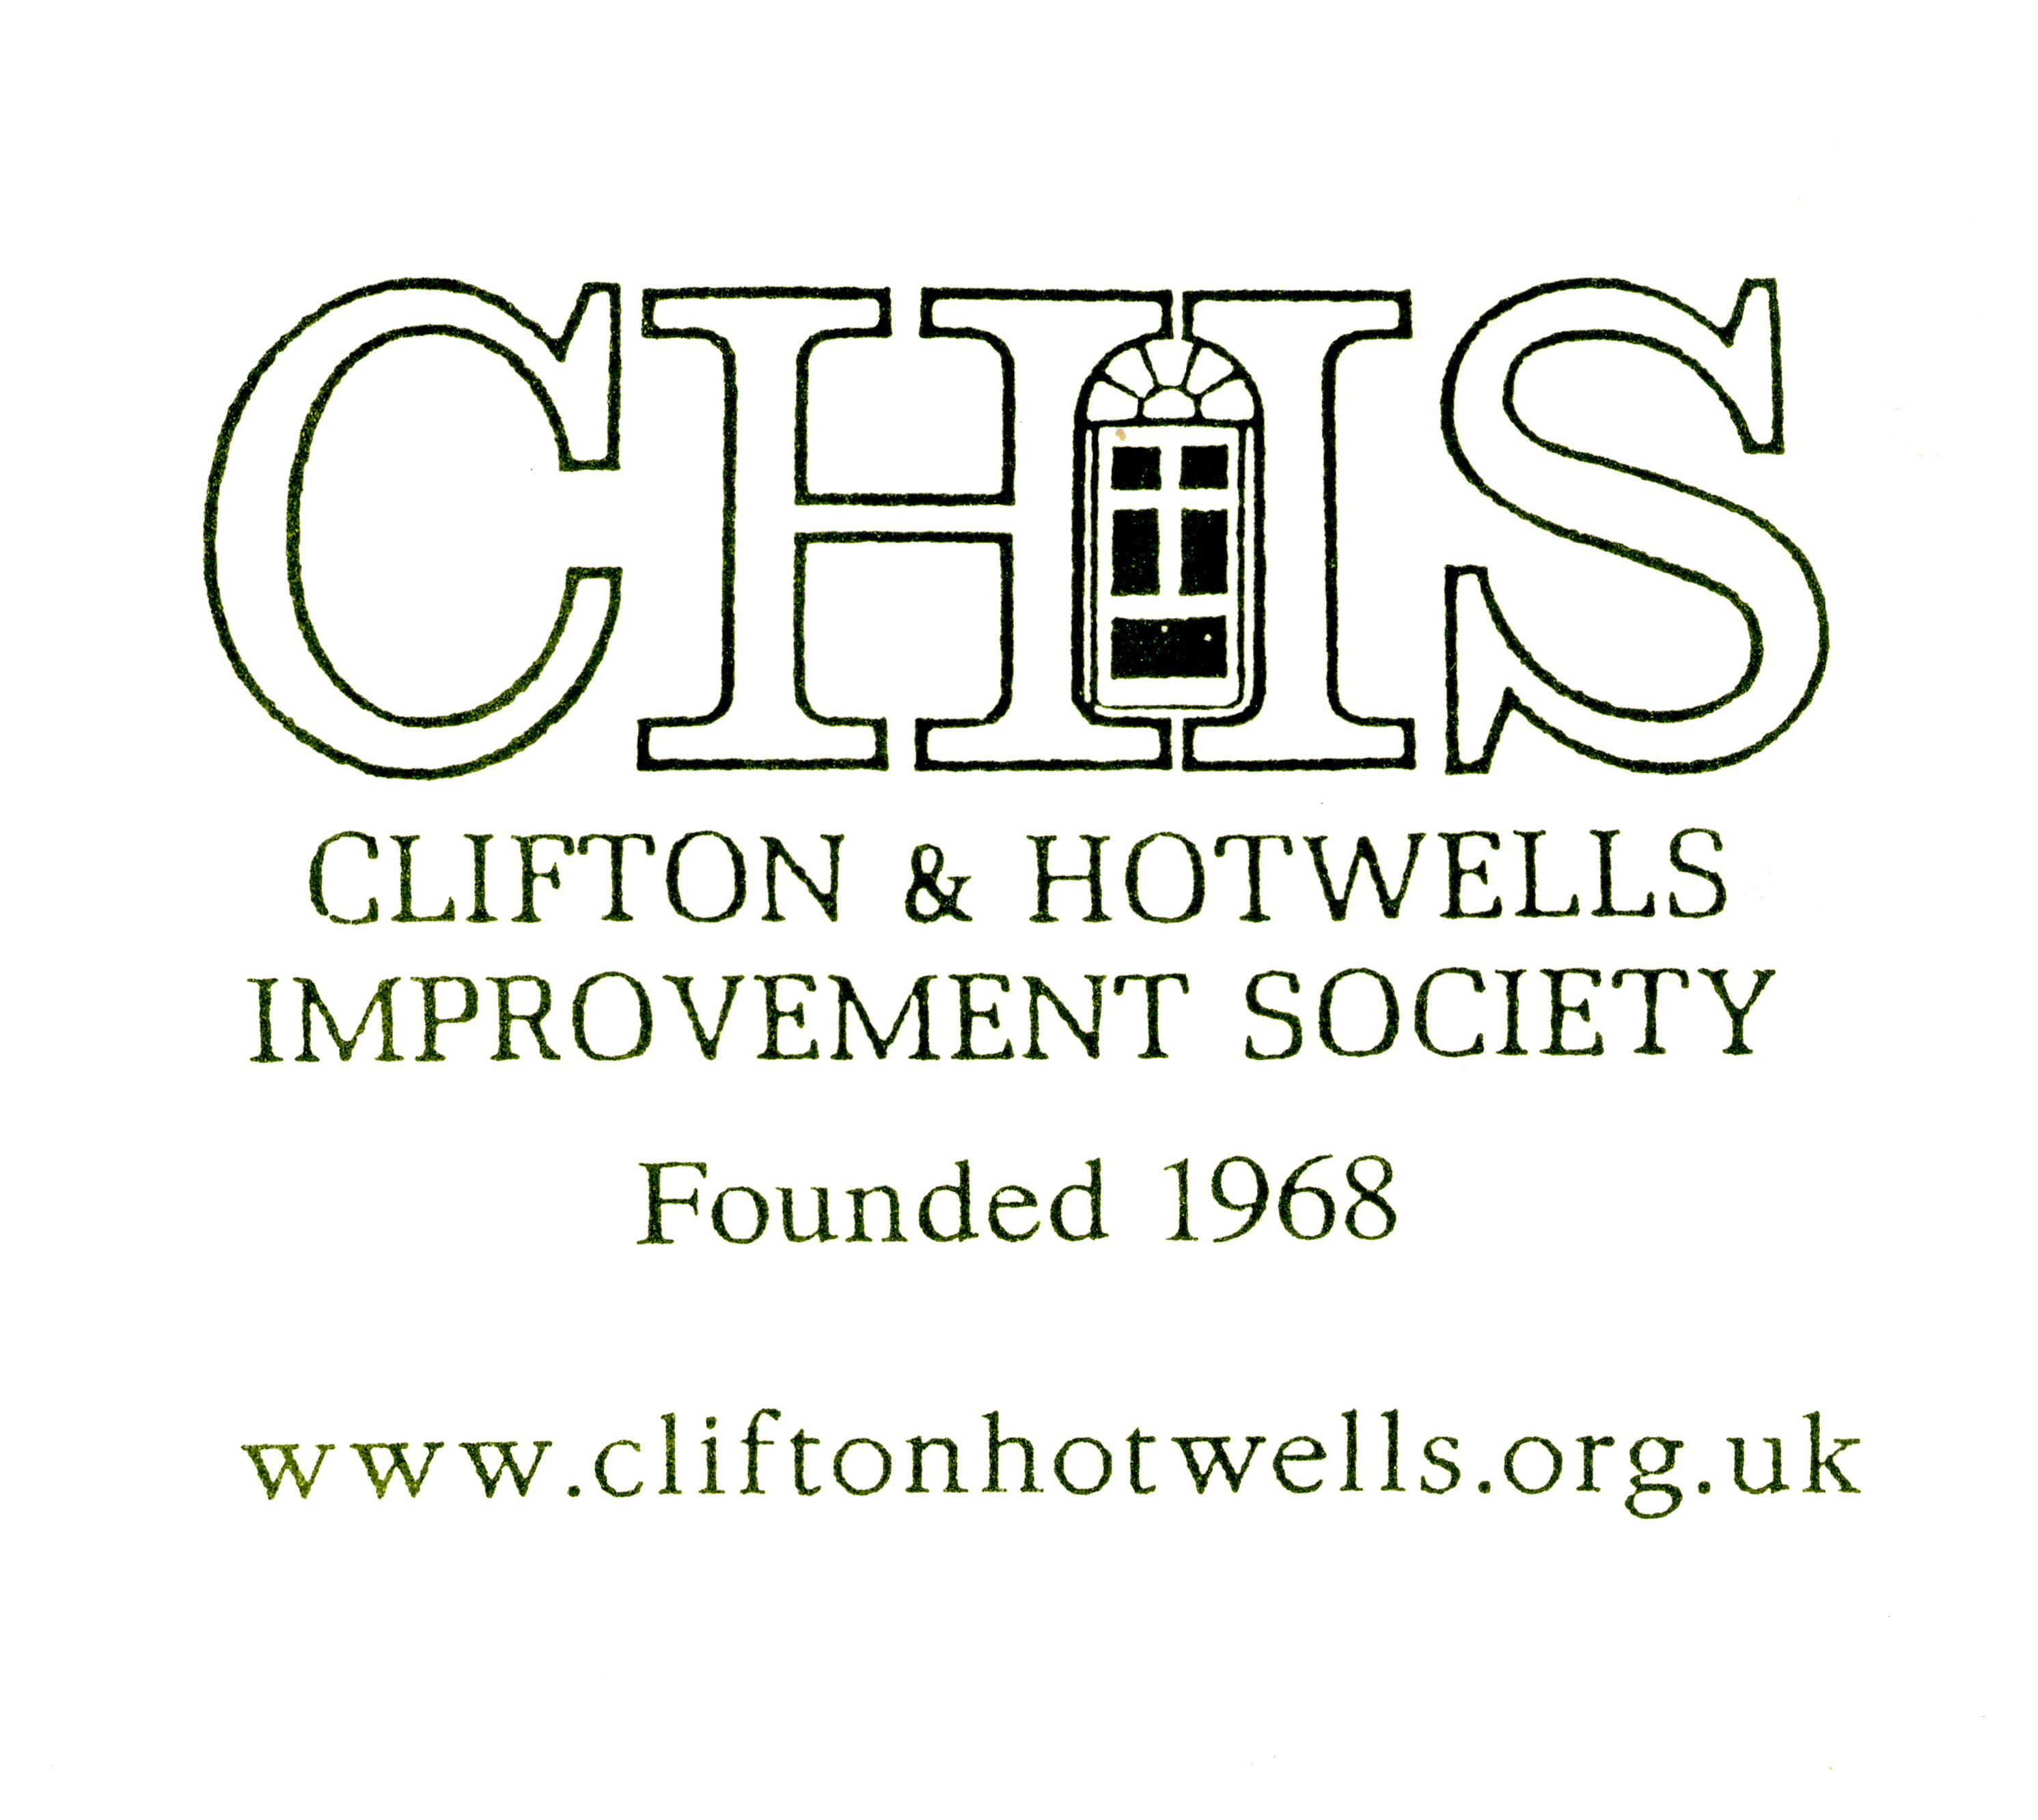

Please complete the relevant sections and return to our Honorary Secretary.

RoseMary Musgrave, Garden Flat, 4 Eaton Crescent, Clifton, Bristol BS8 2EJ
Telephone: 0117 973 1704 Email: r.musgrave10@gmail.com
She will pass the information to the Membership Secretary, Jon Goodland

The minimum annual subscription is £8.00 per household (£15 for organisations) which covers expenses such as the newsletter and talks. If you feel that you can give more to help us improve the area, as many members do, this would be gratefully received and put to good use.

It helps CHIS enormously if you pay by a banker’s order. If you pay income tax at the standard or higher rate, why not Gift Aid your subscription to CHIS? This enables us to take advantage of tax concessions and increase the value of your subscription at no extra cost to yourself.

Name and Address
Name
(block letters please):
Address :
Postcode:
EMAIL address:
Tel No:

Banker’s Order
To (name of your bank): |  |  | Bank PLC
Bank Address :
Postcode:
Please pay Barclays Bank PLC, 86 Queen’s Road, Clifton, Bristol, BS8 1RB (code no. 20-13-34) for the account of Clifton and Hotwells Improvement Society (Account no. 70268348) the sum of
£ |  | now and on 5 May annually thereafter until further notice.
Name of account to be debited :
Account Number :
Signature : |  |  |  |  | Date :

Gift Aid Form

GIFT AID DECLARATION – for past, present & future donations to Clifton and Hotwells Improvement Society (CHIS)
Please treat as Gift Aid donations all qualifying gifts of money made: today, in the past 4 years and in the future (delete if required) I confirm I have paid or will pay an amount of Income Tax and/or Capital Gains Tax for each tax year (6 April to 5 April) that is at least equal to the amount of tax that all the charities or Community Amateur Sports Clubs (CASCs) that I donate to will reclaim on my gifts for that tax year. I understand that other taxes such as VAT and Council Tax do not qualify. I understand the charity will reclaim 25p of tax on every £1 that I give on or after 6 April 2008.

Signature:
Date:
Name :
Address :
Postcode:

This form does NOT need to be witnessed

Payment by Cash or Cheque

I enclose cash or cheque/postal order to Clifton and Hotwells  Improvement Society to the value of : | £

Membership Secretary
Please return the completed form to our Membership Secretary :

RoseMary Musgrave,

Garden Flat,

4 Eaton Crescent,

Clifton,

Bristol BS8 2EJ

